The Study of Jude: Contend for the Faith
The Judgment of False Teachers, Part 3 - Jude 1:14-16

Hermeneutics, Dreams and Visions:
Does God speak through dreams today? Or Can God speak through dreams today?

Prompting: ________________________________________________________________

Revelatory: ________________________________________________________________

Jude presents a case for the judgment of false teachers:
1) God punished unbelievers. 2) God punishes angels. 3) God punishes immorality. 4) The false teachers are sinners who deserve judgment. 5) The false teachers are empty vessels.

6) The false teachers will face judgment at the Lord’s return.
"14 It was also about these that Enoch, the seventh from Adam, prophesied, saying, “Behold, the Lord comes with ten thousands of his holy ones, 15 to execute judgment on all and to convict all the ungodly of all their deeds of ungodliness that they have committed in such an ungodly way, and of all the harsh things that ungodly sinners have spoken against him.” 16 These are grumblers, malcontents, following their own sinful desires; they are loud-mouthed boasters, showing favoritism to gain advantage." (Jude 1:14–16)

The return of the Lord for judgment: (Daniel 7:10-14 and Revelation 20:4)

The coming of the Lord for judgment on all that spoke against Christ

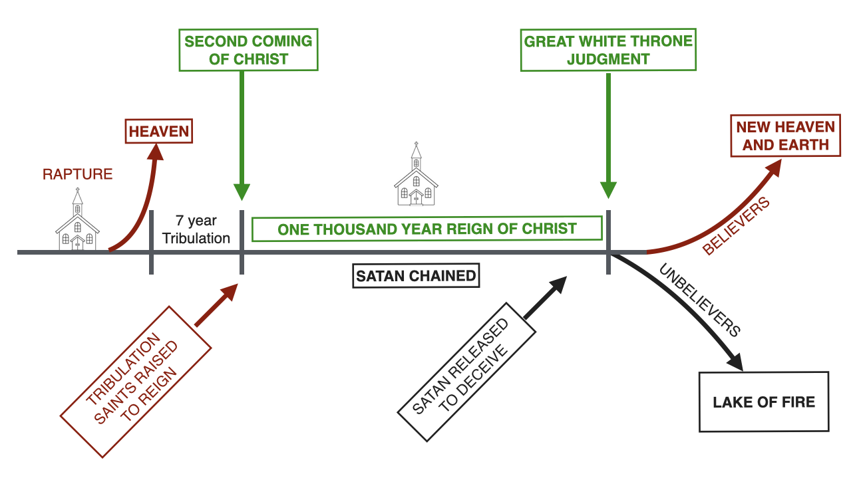

The identity of the false teachers to be judged:
Grumblers: Under the breathe complainers
Malcontents: Fault finders
Boasters: proclaim loudly
Manipulators: Favoritism to gain advantage

