The Study of 1 John: Joy Through Abiding Fellowship
Jesus is Eternal Life – 1 John 1:1-4
Overview of 1 John:
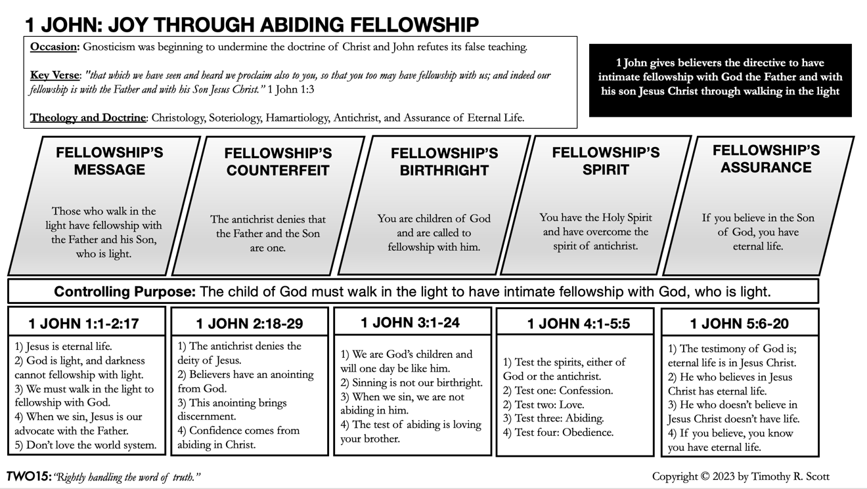

Jesus is Eternal Life:
"1 That which was from the beginning, which we have heard, which we have seen with our eyes, which we looked upon and have touched with our hands, concerning the word of life 2 the life was made manifest, and we have seen it, and testify to it and proclaim to you the eternal life, which was with the Father and was made manifest to us 3 that which we have seen and heard we proclaim also to you, so that you too may have fellowship with us; and indeed our fellowship is with the Father and with his Son Jesus Christ. 4 And we are writing these things so that our joy may be complete."
(1 John 1:1-4)

- The Empirical Evidence of the Life and Resurrection of Jesus Christ. (1 John 1:1)
From the beginning: __________________________________________________________

Heard, seen, and handled: ______________________________________________________

Compare this to Luke 24:36-39

- The Manifestation of Eternal Life. (1 John 1:2)

- The Joy of Fellowship. (1 John 1:3-4)

Discussion Questions:
- Discuss the difference between Historical-Legal Evidence and Empirical Evidence.
- How credible is the testimony of John, and how does this impact your faith?
- What brings you joy? Discuss how Christ’s life can produce joy in your life.

