The Study of James: Contend for the Faith
Planning and the Will of God - James 4:11-17

Decision Making and the Will of God.
God calls us to accept his sovereign will.
God calls us to find in the word of God his moral will and submit to it.
Once we are in the moral will of God, we have freedom to make wise decisions.

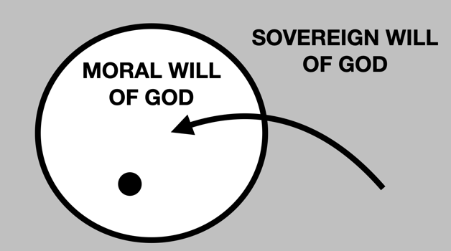

Planning and the Will of God.
"13 Come now, you who say, "Today or tomorrow we will go into such and such a town and spend a year there and trade and make a profit" 14 yet you do not know what tomorrow will bring. What is your life? For you are a mist that appears for a little time and then vanishes. 15 Instead you ought to say, "If the Lord wills, we will live and do this or that." 16 As it is, you boast in your arrogance. All such boasting is evil. 17 So whoever knows the right thing to do and fails to do it, for him it is sin." (James 4:13–17)

Presumptuous planning. (James 4:13-14)

The problem is leaving God out of our plans: Location, Time, Success, and Control.

The problem is limited options:
- Outcome: How do I know what tomorrow will bring?

- Mortality: How long will God allow me to live?

Spiritual planning. (James 4:15-17)

Submission to the _____________________________.

Submission to the ____________________________.

Discussion Questions:
- Why does James expose the presumptuous planner as a sinner? (4:13-17)

- In what ways should the spiritual planner submit to God? And why is this important? (4:15-17)

- Discus with your group what you have learned in this study about how to find God’s will for your life.

